8.19: a) See Exercise 8.21; 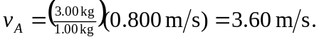

b)

